


International Seminar on
Advanced Remote Sensing Application
（遥感应用国际研讨会）

PROGRAMME （日程）

March 25-26, 2019

Beijing, China

Organized by:
School of Geomatics and Urban Spatial Informatics, Beijing University of Civil Engineering and Architecture (BUCEA), China
（北京建筑大学 测绘与城市空间信息学院）
Supported by
Department of Geomatic Engineering, Istanbul Technical University (ITU), Turkey
（伊斯坦布尔技术大学 地理信息工程学院）
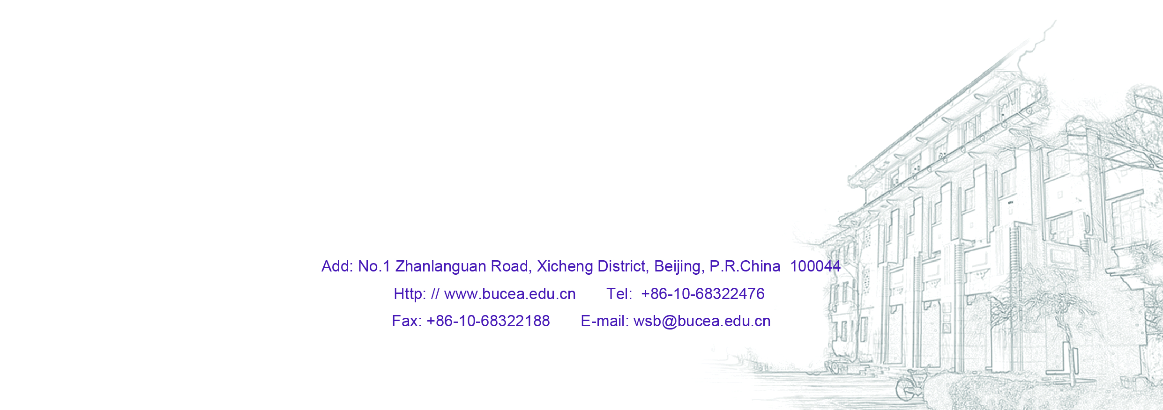

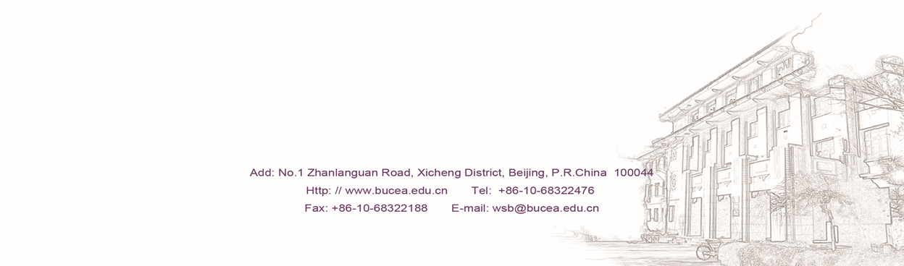


THE SEMINAR
The International Seminar on Advanced Remote Sensing Application is organized by School of Geomatics and Urban Spatial Informatics, Beijing University of Civil Engineering and Architecture (BUCEA). The Seminar will be held in Beijing during March 25-26, 2019. It will consist of lectures, discussions on cutting-edge research, software and applications of remote sensing technologies by scholars from Turkey and China.
Participants of this Seminar include teachers and students of BUCEA, professors from ITU.

Beijing University of Civil Engineering and Architecture (BUCEA)
BUCEA is founded in 1907, with 11 schools. The school of Geomatics and Urban Spatial Information is established in 1936, now offers 3 undergraduate programs, 5 master programs, 1 doctor program and 1 postdoctoral research station.
Istanbul Technical University (ITU)
Founded in 1773 with the name “Mühendishane-i Bahr-i Hümayun” (Imperial School of Naval Engineering) during the reign of Mustafa III, Istanbul Technical University is a prominent and pioneering university of engineering and architecture with many innovative studies in science, technology, research and development. İTÜ, as a university mainly composed of graduate engineering schools and research laboratories, works closely in collaboration with enterprises and other economic and social partners.

AGENDA
Monday, 25 March
Technical Visit 1: Campus
(Moderator: Dr. DU Mingyi, Dean of School of Geomatics and Urban Spatial Informatics)
10:00-11:30 | Visit Campus of BUCEA （参观北建大校园）  Visit School of Geomatics and Urban Spatial Informatics（参观测绘学院）
Technical Session 1
(Moderator: Prof. JIANG Jie, Professor of BUCEA )
13:30-14:10 | Remote Sensing in a Changing World  Dr. Orhan Altan, ISPRS Honorary Member, Professor of ITU
14:10-14:50 | Forest Fire Monitoring Using Remote Sensing Technology  Dr. Filiz Sunar, Professor of ITU
14:50-15:30 | Group Photo and Tea Break （集体照、茶歇）
15:30-15:50 | Efforts on Regional Mapping with Chinese Satellite Imagery （区域测图）  Dr. JIANG Jie, Professor of BUCEA （蒋捷）
15:50-16:10 | Research on Global Land Cover Map Updating (地表覆盖增量更新)  Dr. ZHU Ling, Associated Professor of BUCEA （朱凌）
15:10-16:30 | Damage Detection and Analysis of Urban Bridges using TLS, Ground-based Microwave Interferometry, and PS-InSAR (非接触式桥梁健康检测)  Dr. LIU Xianglei, Associated Professor of BUCEA （刘祥磊）
16:30-17:30 | Discussion
Tuesday, 26 March
Technical Visit 2: Labs of BUCEA
(Moderator: Dr. HOU Miaole, Professor of BUCEA )
10:00-11:30 | Visit Lab of Architectural Heritage Protection （参观数字遗产实验室）  Dr. HOU Miaole, Professor of BUCEA. （侯妙乐）
Technical Session 2
(Moderator: Prof. JIANG Jie, Professor of BUCEA )
13:30-14:10 | Space for Sustainable Development Goals  Dr. Orhan Altan, ISPRS Honorary Member, Professor of ITU
14:10-14:50 | Assessment of Rapid Urbanization by Remote Sensing  Dr. Filiz Sunar, Professor of ITU
14:50-15:30 | Tea Break
15:30-15:50 | Multi-Feature Object-based Change Detection Using Self Adaptive Weight Change Vector Analysis（变化检测）  Dr. CHEN Qiang, Lecture of BUCEA （陈强）
15:50-16:10 | Assessment of Land Cover Components’ Impacts on the Urban Thermal Environment (城市热岛 )  Dr. Cai Guoyin, Associated Professor of BUCEA （蔡国印）
16:10-16:30 | Urban Functional Zone Recognition Based on Tensor Decomposition for Mobile Phone Positioning Data  Dr. GUO Xian, Lecture of BUCEA （郭贤）
16:30-17:30 | Discussion

Orhan ALTAN
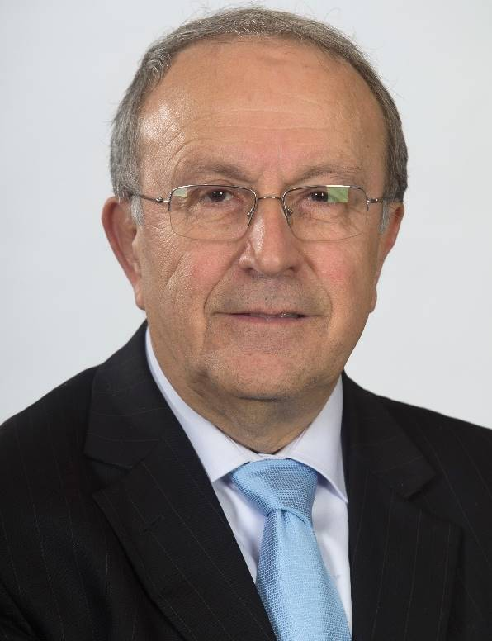
Honorary Member of ISPRS, Member of the Executive Board of the International Council for Science, World Bank Consultant on the improving resilience and resilience impact of national land and geospatial systems, Work Package Leader at different EU Projects, Corresponding member of the German Geodetic Commission at the Bavarian Academy of Sciences and co-chair of the Advisory Board for Geodesy. Member of the International Astronautical Academy.
Published more than 200 scientific papers in scientific journals and conferences, and editor or co-editor of more than 20 international books. “Guest Professor” in Stuttgart, Berlin, Munich Technical Universities (Germany), ETH-Zurich (Switzerland) and Wuhan University (China).
1988- 2013 University Professor; And several times Head of Department of Geodesy and Photogrammetry
1994-1997 Vice-Dean of the Faculty of Civil Engineering for 2 periods
2000-2006 CIPA “International Committee of Architectural Photogrammetry” Executive Board Member
2000-2004 ISPRS Congress Director/Organizer of the 2004 Congress in Istanbul.
2004-2008 Secretary General of ISPRS
2008-2012 President of ISPRS
2012-2016 1st Vice President of ISPRS

Ayse Filiz Sunar


Professor, Geomatics Engineering Department, Istanbul Technical University, Civil Engineering Faculty. She was president ISPRS Technical Commission VII (Remote Sensing) during 2012-2016.

